Calling the next Victorian Government to Maintain Gender Equity Push

Victoria’s 12 Women’s Health Services (WHSs) have released our 2022 Victorian Election Platform. The platform puts forward three key actions to improve women’s health, safety and wellbeing in Victoria.
We need to build upon the last 30 years of reform including the recent significant reform to our family violence system, gender equity policy and practice, and women’s health.
Together the WHSs are calling on all parties at the forthcoming Victorian State Election to take action on three key pillars of policy:
- Sustain, embed and expand the Gender Equality Act
- Make healthcare equitable for all
- Address stigma and stereotypes in our gender-segregated labour market
“We know that inequity is rooted in the systems and structures that embed discrimination and negative gender stereotypes,” said WHIN CEO Helen Riseborough. “These structures and systems are pervasive and impact all aspects of our community and economy.”
Women take significantly more carers’ leave, use flexible working arrangements, and are still impacted by the gender pay gap. They also experience more mental health issues, are admitted to hospital with self-harm more than men and we have seen the rates of heart disease and dementia significantly increase in the last 5 years.
From a workforce perspective, the women are overly represented in under-paid industries - care, social services, education and health work. “Until we confront this gendered view of work we will not be able to care for the workforce that cares and supports all of us,” commented Ms Riseborough.
“The good news is that we can do something about this and the Women’s Health Services have come together to outline what we know is key to ensuring that the last 10 years of reform is sustained and improved upon.”
The Victorian Women’s Health Services 2022 Victorian Election Platform: Keeping the Momentum Going is available via our homepage www.whin.org.au
Contact: Helen Riseborough, CEO of Women’s Health In the North (WHIN)
Phone: (03) 9484 1666 Email info@whin.org.au
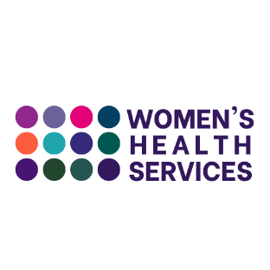

Who are the Victorian Women’s Health Services:
The Victorian Women’s Health Services (WHS) have been at the forefront of gender equality, women’s health and primary prevention for over 30 years. With a Statewide footprint and close connections to community at the local level, WHSs:
- Are a conduit between all women in our community and their health system
- Advocate to our health and social system on how to improve the way they deliver services to community
- Lead regional strategies in sexual and reproductive health and prevention of gender based violence
- Work in collaboration and partnership with community, identifying opportunities to act
- Deliver timely evidence-based programming to work with the health system and structures to apply intersectional gender lens to prevent future pressures on the health system
- Partner with local government, community organisations, and other not for profit agencies to develop and deliver health promotion messages and build capacity on specific health and wellbeing topics
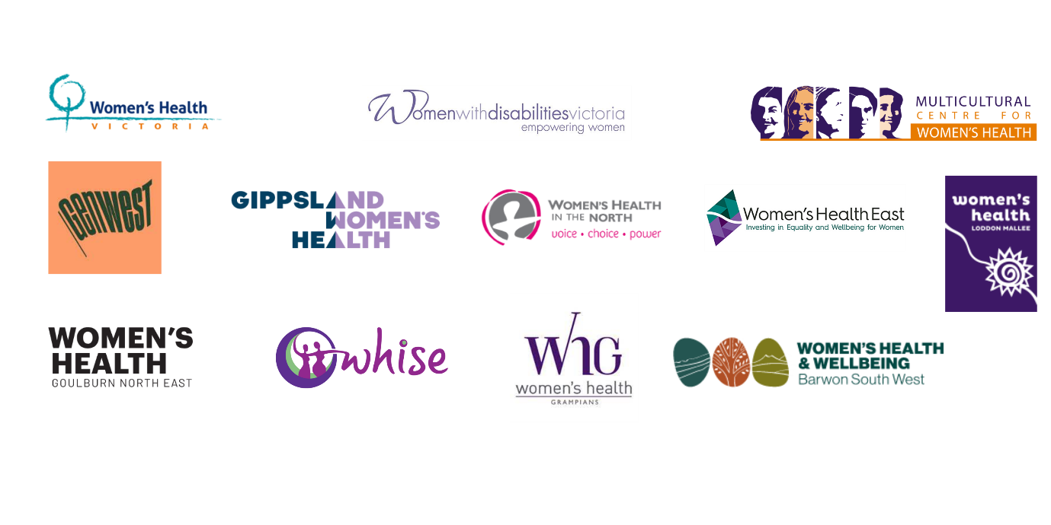
- Translate research into evidence-based policy and practice to inform systems and structures Provide intersectional, gendered advice to government to inform public and social policy that advances women’s health and gender equity.

