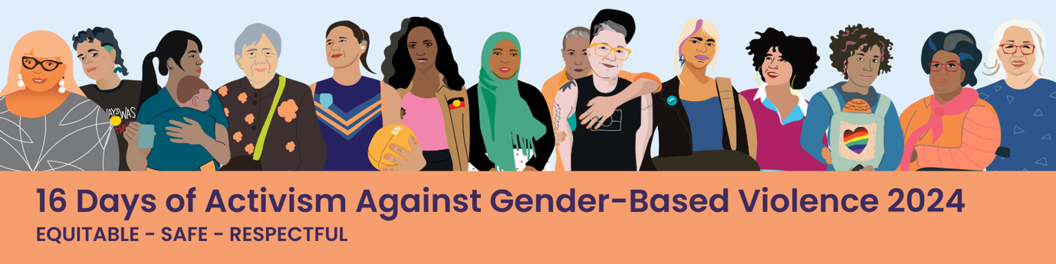

# Equitable, Safe, Respectful Toolkit

Welcome to the ‘Equitable, Safe, Respectful’ campaign toolkit for the Building a Respectful Community (BRC) Partnership to promote a shared vision for a gender equitable, safe and respectful community. This campaign has been prepared for the ‘16 Days of Activism Against Gender Based Violence’ campaign in 2024 – but the resources can be used across the year. These messages are broad and aimed at a general audience, including all those who work, live, study and play in our communities in the northern metropolitan region (NMR) and beyond.

### Contents

About the 16 Days of Activism against Gender-Based Violence Campaign 2

Equitable, Safe, Respectful Campaign 2

Using the toolkit 3

Equitable, Safe, Respectful Campaign Messages 4

Messaging Templates 5

Preparing for Resistance 21

Strategies to Address and Reduce Social Media Backlash 21

Monitoring Guide 24

Response Options 29

Frequently Asked Questions 32

References 33

# About the 16 Days of Activism against Gender-Based Violence Campaign

The 16 Days of Activism Against Gender-Based Violence Campaign (16 Days Campaign) is a global campaign dedicated to ending violence against women and girls. The 16 Days Campaign runs from 25 November, which is the International Day for the Elimination of Violence against Women, to 10 December, International Human Rights Day. These days were chosen to symbolically link violence against women and human rights and to emphasise that violence against women is a violation of human rights. For more information and resources about the 16 Days of Activism against Gender-Based Violence campaign head to [Respect Victoria.](https://www.respectvictoria.vic.gov.au/campaigns/16-days-activism-against-gender-based-violence#bring-16-days-of-activism-to-your-communitynbsp)

# Equitable, Safe, Respectful Campaign

Building on previous years campaigns and in alignment with the [Building a Respectful Community Strategy 2022-2026,](https://www.whin.org.au/wp-content/uploads/sites/2/2022/06/220113-WHIN-BRC-Strategy-F-updated.pdf) WHIN has developed the ‘Equitable, Safe, Respectful’ campaign. The campaign aligns with Respect Victoria’s ‘Respect is’ campaign. The campaign materials have been created to be used for the 16 Days Campaign 2024 and/or build into social marketing efforts across the year.

The campaign highlights primary prevention of gender-based violence work from the NMR and beyond.

The campaign is aimed at a general audience, including all those who work, live, study and play in our communities in the NMR and beyond.

The 2024 campaign includes 16 messages with actions to promote gender equity, challenge gender stereotypes, condone gender-based violence, support reproductive choice and spotlight consent. Stakeholder consultation has informed the increased focus on affirmative consent in the 2024 social media campaign.

Campaign Materials available for use are:

* 16 social media tiles (Facebook, Instagram, LinkedIn)
* 16 messaging templates (see page 5)
* 15 A3 posters
* 4 social media story templates
* Email banner

The resources have been designed to be used as they are, or you may choose to alter the messaging template to showcase your organisation’s work. The tiles have been designed with space to include your organisation’s logo.

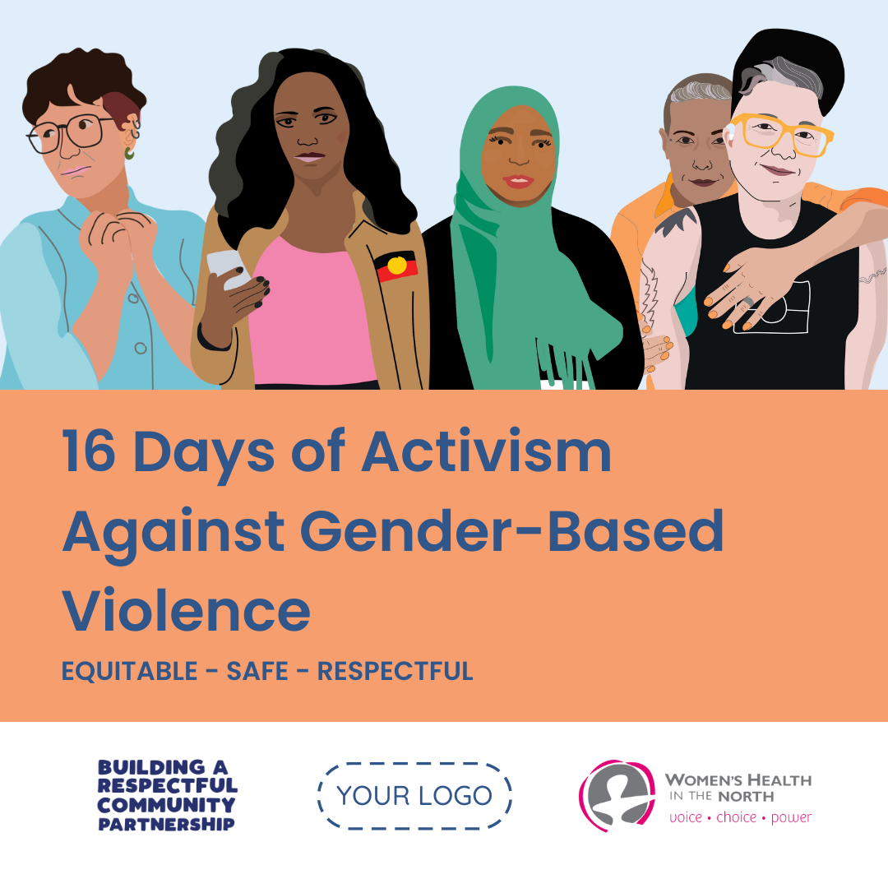

## Using the toolkit

BRC Partners are asked to:

* Use the campaign resources during 16 Days of Activism
* Include the #BuildingaRespectfulCommunity #EquitableSafeRespectful #BRC16Days #16Days #16DaysofActivism #WHIN hashtags in all 16 Days Campaign posts.
* Share the social media tiles on Facebook, LinkedIn and Instagram
* Share the social media tiles on websites, in e-newsletters, posters or in email signatures.
* You may wish to adapt the captions for your organisation e.g. [Your organisation] is proud to be part of the Building a Respectful Community Partnership that is united in building a gender equitable, safe and respectful community #BuildingaRespectfulCommunity #EquitableSafeRespectful #BRC16Days #16Days #16DaysofActivism #WHIN
* Tag WHIN and Respect Victoria in social media posts

|  |  |  |
| --- | --- | --- |
| **Instagram** | [@respectvictoria](https://www.instagram.com/respectvictoria/) | [@womenshealthinthenorth](https://www.instagram.com/womenshealthinthenorth/?img_index=1) |
| **Facebook** | [@RespectVictoria](https://www.facebook.com/RespectVictoria/) | [@WHIN](https://www.facebook.com/whinmelbourne) |
| **LinkedIn** | [Respect Victoria](https://www.linkedin.com/company/respect-victoria/) | [WHIN](https://www.linkedin.com/company/womens-health-in-the-north/mycompany/) |

* Share photos of your 16 Days activities and events with WHIN at [emily.s@whin.org.au](mailto:emily.s@whin.org.au) for inclusion in the BRC Bulletin.
* Complete the campaign survey and submit to [emily.s@whin.org](mailto:emily.s@whin.org) by **COB 23 December.**

## Equitable, Safe, Respectful Campaign Messages

The 16 messages are:

1. 16 Days of Activism against Gender-Based Violence: Equitable, safe, respectful.
2. We all have the right to a gender equitable, safe and respectful north. The Building a Respectful Community Partnership is united in building a gender equitable, safe and respectful community and ending gender-based violence.
3. Raise children free from harmful gender stereotypes.
4. Promote women and gender-diverse people’s financial independence and decision-making.
5. Respect people’s reproductive choices.
6. Respect that everyone has the right to define their gender.
7. Reflect on who does certain chores in your family and why.
8. Support equal, safe, respectful and pleasurable sexual experiences.
9. Learn about the new affirmative consent laws in Victoria.
10. Support flexible work arrangements for all.
11. Practise talking about consent in everyday situations.
12. Model consent in online spaces.
13. Practise responding to boundaries when they are set with you.
14. Challenge transphobic and transmisogynistic jokes and comments.
15. Create safe spaces for communicating desires, boundaries and needs.
16. Every day is a day of activism against gender-based violence.

Messaging Templates  
The messaging templates are intended to provide suggestions and ideas about how to use these materials to support your own 16 Days campaign activities. Low-resolution images are included below for reference, along with supporting text, information, links and hashtags.

Please feel free to adapt and make use of the below resources as best fits in with your own organisation’s campaign plans and prevention of gender-based violence activities.

Low-resolution and high-resolution images can be downloaded from the WHIN website, on the [[Equitable, Safe, Respectful page](https://www.whin.org.au/brc-16-days-of-activism/campaign-resources/)￼](https://www.whin.org.au/resources/preventing-gender-based-violence/).

|  |  |
| --- | --- |
| **Message 1: 16 Days of Activism against Gender-Based Violence: Equitable, safe, respectful** | |
| **Tile** |  |
| **Alternative text** | A diverse group of women and gender-diverse people above the text, ‘16 Days of Activism against Gender-Based Violence: Equitable – Safe – Respectful’. |
| **Suggested Caption** | Everyone has the right to feel equal, safe, and respected.  Unfortunately, women and gender-diverse people often face violence in their homes, their communities and their workplaces.  Today is the International Day for the Elimination of Violence against Women which marks the start of 16 Days of Activism against Gender-Based Violence.  This #16Days we will be sharing simple, everyday actions that we can all take to build a gender equitable, safe and respectful community for all. |
| **Hashtags** | #BuildingaRespectfulCommunity #EquitableSafeRespectful #BRC16Days #16Days #16DaysofActivism #WHIN |
| **Relevant link(s)** | [www.whin.org.au/brc/16-days-of-activism-2024/](http://www.whin.org.au/brc/16-days-of-activism-2024/) |

|  |  |
| --- | --- |
| **Message 2: We all have a right to a gender equitable, safe and respectful north. The Building a Respectful Community Partnership is united in building a gender equitable, safe and respectful community and ending gender-based violence.** | |
| **Tile** |  |
| **Alternative text** | A collection of buildings and a rainbow underneath the text ‘We all have a right to a gender equitable, safe and respectful north. The Building a Respectful Community Partnership is united in ending gender-based violence and building a gender equitable, safe and respectful community’. Text across the top of the image says,‘16 Days of Activism against Gender-Based Violence 2024’. |
| **Caption** | Everyone has the right to feel equal, safe, and respected in their community.  [Your organisation] is proud to be part of the Building a Respectful Community partnership that is united in building a gender equitable, safe and respectful community.  We know that it’s up to all of us, as individuals and organisations, to take steps to build a world where women and gender-diverse people thrive.  Stayed tuned over the next 14 days, we will be sharing simple actions that we can take every day to build a gender equitable, safe and respectful community. |
| **Hashtags** | #BuildingaRespectfulCommunity #EquitableSafeRespectful #BRC16Days #16Days #16DaysofActivism #WHIN |
| **Relevant link(s)** | [www.whin.org.au/brc/](http://www.whin.org.au/brc/) |

|  |  |
| --- | --- |
| **Message 3: Raise children free from harmful gender stereotypes** | |
| **Tile** |  |
| **Alternative text** | A child with black curly hair and glasses alongside a pile of books and a fidget spinner sits next to the text ‘Promote gender equity for children of all ages’. Text across the top of the image says, ‘16 Days of Activism against Gender-Based Violence 2024’. |
| **Suggested Caption** | Every child should feel equal, safe, and respected.  However, rigid gender stereotypes limit our children from a young age.  Calling girls “bossy” when they express their opinions, not allowing boys to cry or children to express their gender in ways that affirm them can feed into cultures that support gender-based violence, transphobia and homophobia. When children feel pressured by, or don’t meet, social expectations of their gender it can be unsafe for them and others.  We know that celebrating positive gender norms and children’s authentic selves helps children challenge harmful gender stereotypes and learn about respectful relationships.  To learn more about local work, read about the projects Grade 6 students at Fitzroy North Primary School developed on gender equality and challenging gender stereotypes. |
| **Hashtags** | #BuildingaRespectfulCommunity #EquitableSafeRespectful #BRC16Days #16Days #16DaysofActivism #WHIN |
| **Relevant link(s)** | <https://newsletters.naavi.com/i/MLrx8GN/term-3-week-10/page/4> |

|  |  |
| --- | --- |
| **Message 4: Promote women and gender diverse people’s financial independence and decision making** | |
| **Tile** |  |
| **Alternative text** | A woman with black curly hair stands next to the text ‘Promote women’s financial independence and decision-making’. Text across the top of the image says, ‘16 Days of Activism against Gender-Based Violence 2024’. |
| **Suggested Caption** | Each of us has the right to feel equal, safe, and respected in our lives.  However, often men control decision-making which limits women and gender-diverse people’s decision making. This creates an imbalance in power and resources that can easily be abused.  By promoting women and gender diverse people’s financial independence and decision-making in public life and relationships we can build a more equal, safe and respectful community.  To learn more about local work promoting economic equality, take a look at WHIN’s ‘Let’s Talk Money’ program which provides financial education to support multicultural women on their journey towards financial security. |
| **Hashtags** | #BuildingaRespectfulCommunity #EquitableSafeRespectful #BRC16Days #16Days #16DaysofActivism #WHIN |
| **Relevant link(s)** | <https://economicequality.org.au> |

|  |  |
| --- | --- |
| **Message 5: Respect people’s reproductive choices** | |
| **Tile** |  |
| **Alternative text** | A woman with dark hair and glasses looking at her phone sits next to the text ‘Respect decision-making in relation to reproductive rights’. Text across the top of the image says, ‘16 Days of Activism against Gender-Based Violence 2024’. |
| **Suggested Caption** | Each of us has the right to feel equal, safe, and respected to make decisions in relation to our bodies and our health.  Shame and stigma about abortions create an environment where people feel pressured or judged for making choices about their own bodies. Some people use this as a way to control the decisions of others; this is called reproductive coercion.  We know that normalising open, respectful conversations about reproductive rights creates a supportive environment that respects each person’s right to make their own decisions without facing judgement or stigma. Together, we can make it clear that reproductive rights are human rights.  To learn more about pregnancy options, contraception and sexual health, visit the 1800 My Options website via the link in their bio. |
| **Hashtags** | #BuildingaRespectfulCommunity #EquitableSafeRespectful #BRC16Days #16Days #16DaysofActivism #WHIN |
| **Relevant link(s)** | <https://www.1800myoptions.org.au> |

|  |  |
| --- | --- |
| **Message 6: Respect that everyone has the right to define their gender** | |
| **Tile** |  |
| **Alternative text** | A person with blonde and pink hair with a skateboard and she/her pronoun badge stands next to the text ‘Respect that people have the right to define their own gender’. Text across the top of the image says, ‘16 Days of Activism against Gender-Based Violence 2024’. |
| **Suggested Caption** | Each of us has the right to feel equal, safe, and respected to be our authentic selves.  We know that social norms and rigid definitions of gender can lead to discrimination and violence towards trans and gender diverse people. The prejudice or discrimination against trans people based on their transgender identity is called transphobia.  We know that understanding transphobia, as well as the ways we can each show allyship, can build our ability to make the north more inclusive by supporting our trans and gender diverse communities. To learn more about how we can support inclusion, take a look at The Unsaid Says A Lot Campaign from the Victorian Government, co-designed with trans and gender diverse communities. |
| **Hashtags** | #BuildingaRespectfulCommunity #EquitableSafeRespectful #BRC16Days #16Days #16DaysofActivism #WHIN |
| **Relevant link(s)** | <https://www.vic.gov.au/theunsaid> |

|  |  |
| --- | --- |
| **Message 7: Reflect on who does certain chores in my household and why** | |
| **Tile** |  |
| **Alternative text** | A person with brown and pink hair wearing a baby carrier with a rainbow heart design stands next to the text ‘Reflect on who does certain chores in your household and why’. Text across the top of the image says, ‘16 Days of Activism against Gender-Based Violence 2024’. |
| **Suggested Caption** | Each of us has the right to feel equal, safe, and respected in our home.  When we assume household work and childcare are ‘women’s work’ we feed into rigid gender roles which constructs a culture where violence against women thrives. When people choose not to conform to these rigid gender roles, they are often punished.  Talking about how you share the housework and caring responsibilities in a way that works for everyone in your household helps build relationships that are equitable, safe and respectful for all.  To learn more about local work challenging rigid gender roles, check out healthAbility’s Baby Makes 3 program which builds equal and respectful relationships between new parents. |
| **Hashtags** | #BuildingaRespectfulCommunity #EquitableSafeRespectful #BRC16Days #16Days #16DaysofActivism #WHIN |
| **Relevant link(s)** | <https://assets.healthability.org.au/images/BM3-Whole-of-setting.pdf> |

|  |  |
| --- | --- |
| **Message 8: Support equal, safe, respectful and pleasurable sexual experiences** | |
| **Tile** |  |
| **Alternative text** | A person with long dark hair embraces a pregnant person with curly short hair. They stand next to the text ‘Support equal, safe, respectful and pleasurable sexual experiences, intimacy and relationships’. Text across the top of the image says, ‘16 Days of Activism against Gender-Based Violence 2024’. |
| **Suggested Caption** | Each of us has the right to feel equal, safe, and respected in our sexual experiences.  Expectations about how sex should look, sound, and feel still often centre around social norms that prioritise men’s satisfaction at the expense of mutual respect, safety and pleasure.  By promoting education and media that reflect diverse and respectful representations of sexuality, we can redefine the norms and support more equal and fulfilling relationships and intimacy for people of all genders.  To learn more about media that supports sexual and reproductive health, take a look at *ConSensual* a zine created for young people, by young people as part of the Taking ACtion project. |
| **Hashtags** | #BuildingaRespectfulCommunity #EquitableSafeRespectful #BRC16Days #16Days #16DaysofActivism #WHIN |
| **Relevant link(s)** | <https://www.takingaction.org.au/#zine> |

|  |  |
| --- | --- |
| **Message 9: Learn about the new affirmative consent laws in Victoria** | |
| **Tile** |  |
| **Alternative text** | A woman sits cross legged with her laptop next to the text ‘Learn about the new affirmative consent laws in Victoria’. There is a grey cat in the foreground. Text across the top of the image says, ‘16 Days of Activism against Gender-Based Violence 2024’. |
| **Suggested Caption** | Each of us have the right to feel equal, safe, and respected in our sexual experiences and relationships.  A lack of community understanding about consent and sexual violence means that many of us don't understand our sexual rights and responsibilities and are not well equipped to practice consent.  Understanding the new affirmative consent laws in Victoria helps to create a shared understanding of consent across the community. Knowing our legal rights and responsibilities is part of the foundation for safe, pleasurable, respectful and consensual sexual experiences for all.  To learn more about the new affirmative consent laws in Victoria take a look at the Sexual Assault Services Victoria overview. |
| **Hashtags** | #BuildingaRespectfulCommunity #EquitableSafeRespectful #BRC16Days #16Days #16DaysofActivism #WHIN |
| **Relevant link(s)** | <https://www.sasvic.org.au/consent> |

|  |  |
| --- | --- |
| **Message 10: Support flexible work arrangements for everyone** | |
| **Tile** |  |
| **Alternative text** | Four people are next to the text ‘Support and encourage flexible work arrangements for all’. One person is in a wheelchair. The second is holding a child. The third is taking a phone call. Text across the top of the image says, ‘16 Days of Activism against Gender-Based Violence 2024’. |
| **Suggested Caption** | Each of us has the right to feel equal, safe, and respected in our workplace.  Too often, women and gender-diverse people with disabilities face many barriers in their workplaces due to ableism, sexism and transphobia. Ableism is the system of beliefs, processes and practices that privilege people without disabilities, and disadvantage and exclude people with disabilities  We know that flexible work arrangements support women and gender-diverse people with disabilities to feel equal, safe and respected in our workplace.  Flexible working arrangements also lead to greater gender diversity in senior roles, men taking an increased role in care and domestic duties, improved worker wellbeing and reduced burnout. By encouraging flexible work arrangements for everyone we can build gender equitable, safe, and respectful workplaces for all.  Today is International Day of Persons with Disabilities. To learn more about the experiences of women with disabilities check out Our Watch’s ‘Get Real’ videos. |
| **Hashtags** | #BuildingaRespectfulCommunity #EquitableSafeRespectful #BRC16Days #16Days #16DaysofActivism #WHIN |
| **Relevant link(s)** | https://www.ourwatch.org.au/change-the-story/changing-the-landscape/case-study-videos |

|  |  |
| --- | --- |
| **Message 11: Practise talking about consent in everyday situations** | |
| **Tile** |  |
| **Alternative text** | An older woman with a mobility aid is standing next to the text ‘Practise talking about consent in everyday situations’. There is a dog in the foreground. Text across the top of the image says, ‘16 Days of Activism against Gender-Based Violence 2024’. |
| **Suggested Caption** | Each of us has the right to feel equal, safe, and respected to make decisions about our bodies, our health and our relationships.  Sometimes it can feel challenging to communicate our decisions if we don’t have the language and confidence to talk about consent with others.  By practising communicating about consent in everyday situations, we can build a culture of consent where each of us feel confident and comfortable to express our desires, boundaries and decisions, and respect those of others.  To build your confidence in talking about consent, take a look at the [Consent Can’t Wait](https://www.consent.gov.au/) resources shared by the Federal Government which seek to develop a shared understanding of consent. |
| **Hashtags** | #BuildingaRespectfulCommunity #EquitableSafeRespectful #BRC16Days #16Days #16DaysofActivism #WHIN |
| **Relevant link(s)** | <https://www.consent.gov.au> |

|  |  |
| --- | --- |
| **Message 12: Model consent in online spaces** | |
| **Tile** |  |
| **Alternative text** | A woman wearing a baby carrier sits cross legged using a laptop next to the text ‘Model consent in online spaces’. Text across the top of the image says, ‘16 Days of Activism against Gender-Based Violence 2024’. |
| **Suggested Caption** | Each of us has the right to feel equal, safe, and respected in online spaces.  However, a lack of community understanding about consent in online spaces can lead to inappropriate and illegal sharing of personal information and images, impacting privacy and safety.  By modelling responsible online behaviour and emphasising the importance of seeking permission before sharing content, we build a safer digital environment where a culture of consent is shared and image-based abuse is prevented.  To learn more about digital consent and online safety, take a look at the eSafety Commissioner’s website. |
| **Hashtags** | #BuildingaRespectfulCommunity #EquitableSafeRespectful #BRC16Days #16Days #16DaysofActivism #WHIN |
| **Relevant link(s)** | <https://www.esafety.gov.au/educators/classroom-resources/online-boundaries-and-consent> |

|  |  |
| --- | --- |
| **Message 13: Practise responding to boundaries when they are set with you** | |
| **Tile** |  |
| **Alternative text** | A person with short hair and glasses stands next to the text ‘Practise responding to boundaries when they are set with you’. Text across the top of the image says, ‘16 Days of Activism against Gender-Based Violence 2024’. |
| **Suggested Caption** | Each of us has the right to feel equal, safe, and respected to express our needs and boundaries.  Sometimes people respond poorly to boundaries, either by dismissing them or by reacting defensively, which can lead to harm.  Practising our responses to boundaries is just as important as practising setting them ourselves. We know that this can grow respect and trust, enhance communication, and prevent harm. Respecting boundaries builds a supportive environment where each person’s needs are acknowledged and valued.  To learn more about dealing with boundaries including rejection, take a look at ‘Crushed but Okay’ from the Alannah & Madeline Foundation. |
| **Hashtags** | #BuildingaRespectfulCommunity #EquitableSafeRespectful #BRC16Days #16Days #16DaysofActivism #WHIN |
| **Relevant link(s)** | <https://crushedbutokay.org.au> |

|  |  |
| --- | --- |
| **Message 14: Challenge transphobic and transmisogynistic jokes and comments** | |
| **Tile** |  |
| **Alternative text** | A person with gender affirming surgery scars leans against a stool next to the text ‘Challenge transphobic and transmisogynistic jokes and comments’. There is a dog in the foreground and a plant in the background. Text across the top of the image says, ‘16 Days of Activism against Gender-Based Violence 2024’. |
| **Suggested Caption** | Each of us has the right to feel equal, safe, and respected to be our authentic selves.  Transphobia and transmisogyny are often overlooked or excused, which fuels harmful stereotypes, discrimination and violence towards trans and gender diverse people. Transphobia refers to prejudice or discrimination against trans people based on their transgender identity. Transmisogyny describes transphobic and misogynistic attitudes that target trans women and trans feminine people.  Together, we can make it clear that all trans and gender diverse people are welcome in our communities by speaking out against jokes or comments that fuel discrimination and violence.  To learn more about taking action against transphobia and transmisogyny, take a look at Zoe Belle Gender Collective’s resources to grow your understanding. |
| **Hashtags** | #BuildingaRespectfulCommunity #EquitableSafeRespectful #BRC16Days #16Days #16DaysofActivism #WHIN #ZoeBelle |
| **Relevant link(s)** | <https://zbgc.org.au/resources/zbgc-resources/> |

|  |  |
| --- | --- |
| **Message 15: Create safe spaces for communicating desires, boundaries and needs** | |
| **Tile** |  |
| **Alternative text** | A person in an orange shirt embraces a person in a black singlet, a cap and glasses. They stand next to the text ‘Create safe spaces for communicating desires, boundaries and needs’. Text across the top of the image says, ‘16 Days of Activism against Gender-Based Violence 2024’. |
| **Suggested Caption** | Each of us should feel equal, safe, and respected to express our desires, boundaries and needs.  Discomfort and a lack of safety sometimes prevent us from sharing our thoughts and feelings, particularly when there is unequal power in a relationship or environment.  Creating a safe space to communicate boundaries, desires and needs means creating a space where saying no is respected and there is no fear of harm. We can all practice creating spaces where communication is open, safe and supported.  To learn more about local work that is empowering young people to ensure their sexual experiences are safe, pleasurable, and consensual, take a look at the Taking ACtion project. WHIN has delivered Taking ACtion in partnership with Banksia Gardens Community Services, and works with young people to develop their knowledge and skills to communicate consent. |
| **Hashtags** | #BuildingaRespectfulCommunity #EquitableSafeRespectful #BRC16Days #16Days #16DaysofActivism #WHIN |
| **Relevant link(s)** | <https://www.takingaction.org.au> |

|  |  |
| --- | --- |
| **Message 16: Every day is a day of activism against gender-based violence** | |
| **Tile** |  |
| Alternative text | A diverse group of women and gender-diverse people above the text ‘Every day is a day of activism against gender-based violence: 16 Days of Activism against Gender-Based Violence 2024’. |
| Suggested Caption | Everyone has the right to feel equal, safe, and respected. For every day of our lives, not just for 16.  Today is Human Rights Day which marks the end of 16 Days of Activism against gender-based violence. At [YOUR ORGANISATION] we know that everyone has the right to feel equal, safe, and respected every day of the year.  This is not the case in Australia, where every nine days a woman is killed by her current or former partner. One in two trans and gender-diverse people have experienced sexual violence or coercion. Sadly, the northern metropolitan region has higher family violence rates than the Victorian state average.  By taking action everyday we are all working together to build an equitable, safe, and respectful community for all, where everyone can thrive. |
| Hashtags | #BuildingaRespectfulCommunity #EquitableSafeRespectful #BRC16Days #16Days #16DaysofActivism #WHIN |
| Relevant link(s) | <https://www.whin.org.au/brc/> |

## Preparing for Resistance

The Equitable, Safe, Respectful campaign includes messages on gender equality, preventing gender-based violence, affirmative consent, transphobia, sexual and reproductive health which can all be met with resistance. Thinking about resistance as part of your planning will support you to reduce risk, increase engagement and make progress. This section contains response options and a monitoring guide to support you in responding to resistance and backlash.

The terms ‘backlash’ and ‘resistance’ are at times used interchangeably to refer to any form of resistance towards progressive social change. Resistance is defined as ‘an active pushing back against progressive programs, policies, and perspectives’ (Flood et al, 2018) which refers to a spectrum of responses. Backlash is a term for the resistance, hostility or aggression which can arise as a reaction to change that an individual or group thinks is unnecessary or unjust.

Forms of backlash to the Equitable, Safe, Respectful campaign you might see include:

* open hostility or aggression about your organisation’s commitment and efforts to support gender equality and preventing gender-based violence
* posting incorrect or misleading information
* making disparaging comments about people who choose abortion, or prioritising the ‘rights of the unborn child’
* undermining, trivialising or de-prioritising initiatives and actions aimed at increasing gender equality and the prevention of gender-based violence
* removal of campaign posters.

### Strategies to Address and Reduce Social Media Backlash

The Equitable, Safe, Respectful campaign is designed for use on social media where it is common to experience backlash. There are ways you can plan for and address online backlash which we have outlined below.

WHIN has prepared monitoring guides and response options for different types of resistant comments or posts for Equitable, Safe, and Safe campaign messages which are provided on page 23 and 29.

1. Anticipate Backlash and Be Prepared

Resistance is a normal part of the change process – when things change, many people’s response is to push back because they feel uncertain, threatened or disagree with the change being proposed.

Tips for being prepared:

* Provide whoever is responsible for implementing the campaign with detailed explanation of rationale and relevant facts related to more difficult and complex topics. Review the Monitoring Guide below for additional information about the posts for which your colleagues will need the most support.
* Turn comments be off when they cannot be monitored (e.g. out of business hours).
* Close comments when the next post is published.Identify any vulnerable points within the campaign that may make you open to criticism, and plan how to respond.

1. Determine if you Need to Respond

Take the time to determine if responding is worth it:

* Will a response have a positive effect in the long term?
* Is the resistance comment or post response damaging to the key messages of the campaign? Or damaging to the organisation(s) associated with the campaign?
* Will your response assist in the promotion of the key messages of your campaign?

If you have internal moderation guidelines or communication protocols, use these to inform the decision of whether to respond.

1. Respond as a Unified Team

If you do feel that it will be beneficial to respond, make sure you’ve done your research, know your facts and have spoken with relevant people from your team, from within your own organisation and from partner organisations, before making any public response.

If you have internal moderation guidelines or communication protocols, use these to inform how you respond.

1. Be Authentic and Transparent

Your response should hold true to your organisation’s values and the key messages of the campaign. Take time to address any systemic, underlying issues and prepare a response that is authentic, honest, transparent and proactive – also comprehensive.

[Respect Victoria](https://www.respectvictoria.vic.gov.au/sites/default/files/documents/202409/RV_16Days_Toolkit_2024_final.pdf) (2024) recommends using values-based messaging to develop your response and their [16 Days toolkit](https://www.respectvictoria.vic.gov.au/sites/default/files/documents/202409/RV_16Days_Toolkit_2024_final.pdf) provides the below example of how to do this in response to the common resistance question, ‘what about violence against men?’.

|  |  |
| --- | --- |
| **Vision** | I agree with you that all forms of violence and discrimination are unacceptable. |
| **Barrier** | Men and women experience family violence, most commonly from a male perpetrator. This campaign focuses on violence against women because there is clear evidence that women experience violence at disproportionate rates. Women also experience casual and structural sexism daily in a way that men do not. Most family and gender-based violence is perpetrated by cisgender men against women, children, LGBTIQ+ people – as well as other men. 95% of all victims, regardless of gender, experience violence from a male perpetrator. |
| **Solution** | Advocating for the safety, equality and rights of women doesn’t detract from the safety, equality and rights of others. We are trying to create a society where we are all safe, equal and respected – which means challenging the underlying conditions that drive violence against women. |

**Additional Resources:**

* [Dealing with backlash (Our Watch](https://drive.google.com/file/d/1m0Yd1IeRCX0quzWuQyAyORFYR-2ntW_8/view))
* [Resistance and backlash in primary prevention of violence against women](https://www.ourwatch.org.au/resistance-and-backlash-in-primary-prevention) (Our Watch)
* [Engaging Men: Reducing Resistance and Building Support](https://drive.google.com/file/d/12F4jsWa0XhiEIuwqBBnJCbiK6BoaBWjM/view) (Flood et al, 2021)
* [(En)countering resistance: Strategies to respond to resistance to gender equality initiatives (Vic Health)](https://drive.google.com/file/d/1dOoe-pWsCn-4_I0IlDBU0T6VJyXmdfpY/view)
* [Managing backlash against women’s and LGBT+ rights movements in the Commonwealth](https://drive.google.com/file/d/1YXXSBfNc3HMzUP1uVbEAkz0vGYvaj7xw/view) (Edge Effect)
* [Facing resistance in your work (Safe and Equal)](https://safeandequal.org.au/working-in-family-violence/prevention/facing-resistance/?utm_source=RVToolkit&utm_medium=resources&utm_campaign=16-days-activism-toolkit)
* [Overcoming Resistance and Backlash](https://safeandequal.org.au/resources/overcoming-resistance-and-backlash-a-guide-for-primary-prevention-practitioners/?utm_source=RVToolkit&utm_medium=resources&utm_campaign=16-days-activism-toolkit) (Safe and Equal)

### Monitoring Guide

The below table provides a monitoring overview of the campaign, with potential backlash, level of monitoring required, and further information for each campaign message. The monitoring guide is for use by the person or team in your organisation who is responsible for implementing the social media campaign.

| **Message** | **Post Content** | **Backlash Analysis** | **Monitoring Needs** | **Further Information** |
| --- | --- | --- | --- | --- |
| 1 | 16 Days of Activism against Gender-Based Violence: Equitable, safe, respectful | Introduces the campaign which should be acceptable to target audience. Mentions gender-based violence which may produce some values-based comments or misinformation. | Light/regular monitoring | * [Respect Victoria](https://www.respectvictoria.vic.gov.au/campaigns/16-days-activism-against-gender-based-violence) * [Safe and Equal Fast Facts](https://safeandequal.org.au/resources/fast-facts-2023/) |
| 2 | We all have the right to a gender equitable, safe and respectful north. The Building a Respectful Community Partnership is united in building a gender equitable, safe and respectful community and ending gender-based violence. | Should be acceptable to our target audience. May result in some values-based comments or misinformation. | Light/regular monitoring | * [BRC webpage](https://www.whin.org.au/brc/) |
| 3 | Raise children free from harmful gender stereotypes | Should be acceptable to our target audience. May result in some values-based comments or misinformation, such as ‘I don’t think it is appropriate to talk to children about this’. Mention of transphobia and homophobia may attract trolls. | Frequent monitoring and managing comments | * [Our Watch RR education](https://www.ourwatch.org.au/education/the-evidence-for-respectful-relationships-education) * [The Line](https://www.theline.org.au/gender-stereotypes-and-young-people/) |
| 4 | Promote women and gender-diverse people’s financial independence and decision-making | Should be acceptable to our target audience. May result in some values-based comments or misinformation. Mention of gender-diverse people may attract trolls. | Frequent monitoring and managing comments | * [WGEA Pay Gap Data](https://www.wgea.gov.au/pay-and-gender/gender-pay-gap-data) * [Economic Equality Discussion Paper](https://economicequality.org.au/wp-content/uploads/2024/04/economic-equality-discussion-paper-web-compressed.pdf) |
| 5 | Respect people’s reproductive choices | Although acceptable to our target audience, it will likely also bring values-based attacks, unhelpful trolling or abuse. May also bring out misinformation that needs to be corrected. | Frequent monitoring and managing comments | * [1800 My options](https://www.1800myoptions.org.au/information/abortion) * [Better Health Abortion in Victoria](https://www.betterhealth.vic.gov.au/health/healthyliving/abortion-in-victoria) |
| 6 | Respect that everyone has the right to define their gender | High-risk post. Likely to attract transphobic trolls. Positive or neutral comments may still contain misinformation. Likely to get values-based attacks and content-based trolls. | High frequency monitoring. Disabling comment section when unable to be monitored. | * [Fuelling Hate Report](https://transjustice.org.au/wp-content/uploads/2023/08/Fuelling-Hate-Anti-Trans-Abuse-Harassment-and-Vilification-WEB-SINGLES-1-1.pdf) |
| 7 | Reflect on who does certain chores in your family and why | Should be acceptable to our target audience. May result in some values-based comments or misinformation. | Light/regular monitoring | * [Australian Bureau of Statistics](https://www.abs.gov.au/media-centre/media-releases/females-do-more-unpaid-work-males-do-more-paid-work#:~:text=%E2%80%9COn%20average%2C%20females%20spent%204,70%20per%20cent%20of%20females.) Time Use Survey * [WGEA Unpaid Labour Report](https://www.wgea.gov.au/sites/default/files/documents/australian-unpaid-care-work-and-the-labour-market.pdf) |
| 8 | Support equal, safe, respectful and pleasurable sexual experiences | Mention of all gender may attract transphobic trolls. May result in some values-based comments or misinformation. | Frequent monitoring and managing comments | * [UNESCO, UNAIDS Secretariat, UNFPA, et al. *International technical guidance on sexuality education: An evidence-informed approach*](https://unesdoc.unesco.org/ark:/48223/pf0000260770) * [Zaneva, M., Philpott, A., Singh, A., Larsson, G., & Gonsalves, L. (2022). What is the added value of incorporating pleasure in sexual health interventions? A systematic review and meta-analysis.](https://journals.plos.org/plosone/article?id=10.1371/journal.pone.0261034) |
| 9 | Learn about the new affirmative consent laws in Victoria | Should be acceptable to our target audience. May result in some values-based comments or misinformation. | Light/regular monitoring | * [Vic Gov Media Release](https://www.premier.vic.gov.au/affirmative-consent-model-now-law-victoria) * [Sexual Assault Services Vic](https://www.sasvic.org.au/consent) |
| 10 | Support flexible work arrangements for all | Should be acceptable to our target audience. May result in some values-based comments or misinformation. | Light/regular monitoring | * [WGEA Flexible Work](https://www.wgea.gov.au/flexible-work) * [Commission for GE in the public sector: Gender and Employees with Disabilities](https://www.genderequalitycommission.vic.gov.au/intersectionality-work/chapter-3-gender-and-employees-disabilities) * [Our Watch ‘Get Real’ Videos](https://www.ourwatch.org.au/change-the-story/changing-the-landscape/case-study-videos) * [WDV Fact Sheets](https://www.wdv.org.au/publications-resources/wdv-fact-sheets/) |
| 11 | Practise talking about consent in everyday situations | Should be acceptable to our target audience. May result in some values-based comments or misinformation. | Light/regular monitoring | * [Consent Can’t Wait campaign](https://www.consent.gov.au/) |
| 12 | Model consent in online spaces | Should be acceptable to our target audience. May result in some values-based comments or misinformation. | Light/regular monitoring | * [Esafety Commission](https://www.esafety.gov.au/educators/classroom-resources/online-boundaries-and-consent) |
| 13 | Practise responding to boundaries when they are set with you | Should be acceptable to our target audience. May result in some values-based comments or misinformation. | Light/regular monitoring | * [Crushed but ok](https://crushedbutokay.org.au/) |
| 14 | Challenge transphobic and transmisogynistic jokes and comments | High risk post. Likely to attract transphobic trolls. Positive or neutral comments may still contain misinformation. Likely to get values-based attacks and content-based trolls. | High frequency monitoring. Disabling comment section when unable to be monitored. | * [Fuelling Hate Report](https://transjustice.org.au/wp-content/uploads/2023/08/Fuelling-Hate-Anti-Trans-Abuse-Harassment-and-Vilification-WEB-SINGLES-1-1.pdf) * [Allyship in Action Forum Report](https://www.whin.org.au/wp-content/uploads/sites/2/2024/09/Allyship-in-Action-paper-2.pdf) |
| 15 | Create safe spaces for communicating desires, boundaries and needs | Should be acceptable to our target audience. May result in some values-based comments or misinformation. | Light/regular monitoring | * [Consensual Zine](https://www.takingaction.org.au/#zine) |
| 16 | Every day is a day of activism against gender-based violence | High risk post. Likely to attract transphobic trolls. Positive or neutral comments may still contain misinformation. Likely to get values-based attacks and content-based trolls. | High frequency monitoring. Disabling comment section when unable to be monitored. | * [Fuelling Hate Report Media Release](https://transjustice.org.au/fuelling-hate-report-blog/) * [Safe and Equal Fast Facts](https://safeandequal.org.au/resources/fast-facts-2023/) * [Women’s Health atlas](https://victorianwomenshealthatlas.net.au/#!/atlas/Violence%20Against%20Women/V/Intimate%20Partner%20Violence/V_05/2022%20Rate%20(per%2010,000)/464/F/state/all/false) * [Personal Safety Survey](https://www.abs.gov.au/statistics/people/crime-and-justice/personal-safety-australia/latest-release) |

### Response Options

The below table considers a range of different interactions you might experience with your posts, from low risk to high risk, and provides examples of how you might respond to maximise positive engagement and mitigate any risks to the campaign, your staff, your organisation or your followers.

| **Type of comment**  **or post** | **Example** | **Potential response** |
| --- | --- | --- |
| **Low Risk** | | |
| Sales/spam | *“Visit my business page XXX for huge discounts on women’s clothing”* | Delete without notification. |
| Compliment | *“I just want to say how much I love this campaign and the work you do. Keep it up!”* | Thank the person and let them know you appreciate the time it took to make the comment and you’ll pass it on.    Take a screenshot and share the love with your team! Like and reshare as a post at your discretion and with permission. |
| Neutral comment | A response to a question you posed  *‘Interesting’* or @tags a friend in a post | Like their post/comment    And/or Respond (eg. “us too”, “thanks for your thoughts”) |
| Query/question | *“Where can I find more information about affirmative consent laws?”*    *“What sexual and reproductive work does your organisation do?”* | Answer the question, tag the original poster.    If you don’t know the answer let them know it’s been seen and promise to follow up. Or direct them to further information with a link. If you are unsure of further information contact [Emily.s@whin.org.au](mailto:Emily.s@whin.org.au)    Respond accordingly where you can. |
| Neutral or positive comment with misinformation | *“I believe that people should be able to make choices for their own body, but girls are using abortion as contraception nowadays”*    *“I believe that talking about gender-based violence is important. However, what about rates of violence against men which are just as high?’* | Thank them for their comment and correct their statement with the view/ policy of the organisation.  Direct them to further information with a link. If you are unsure of further information refer to the monitoring guide or contact [Emily.s@whin.org.au](mailto:Emily.s@whin.org.au) |
| **Medium Risk** | | |
| Value’s based attack on the content. | *“I just don’t think it’s right to be talking about (insert topic) to children”.* | Acknowledge that everyone has their own beliefs and values, but that our content is drawn from evidence and current research. Direct them to further information with a link. |
| Complaint | *“I was at your service today and your service staff are so rude. I’m never going back”.*    *“Something about bins not being collected for two weeks..”* | Take a screenshot.    Acknowledge, apologise and act to resolve the issue/complaint. Refer to appropriate person. Provide appropriate phone or email contact details if more information needed. |
| Politically motivated | *“This campaign shouldn’t be funded by the government and taxpayers”*  *“XXXX MP is proud to support your campaign and launch it today”.* | At your discretion, depending on the nature of the comment.    If a negative comment you may delete and notify poster if it violates “house rules”.    If a positive comment you may also consider it a compliment and thank or acknowledge the poster. |
| **High Risk** | | |
| Unhelpful, negative, attack or trolling | *“Bloody X organisation at it again, what about the violence against men? Feminazis.”* | Take a screenshot of the comment.    Remind them of the page guidelines and that they are welcome to leave/unfollow the page.    Delete and block – especially if repeat offender or dependant on nature of the comment. |
| Vulgar, explicit, threatening or racist comments |  | Take a screenshot of the comment.  Delete the comment  Remind other commenters on thread that these comments will be deleted. Direct people back to page guidelines.  Consider blocking if repeat offender.  Any threats of violence should be escalated to police, legal or management for further advice. |

## Frequently Asked Questions

**Can I put my organisation’s logo on the social media tiles?**

Yes! The social media tiles have been developed to include space for your organisation’s logo at the bottom of the tile, between the Building a Respectful Community logo and Women’s Health In the North logo.

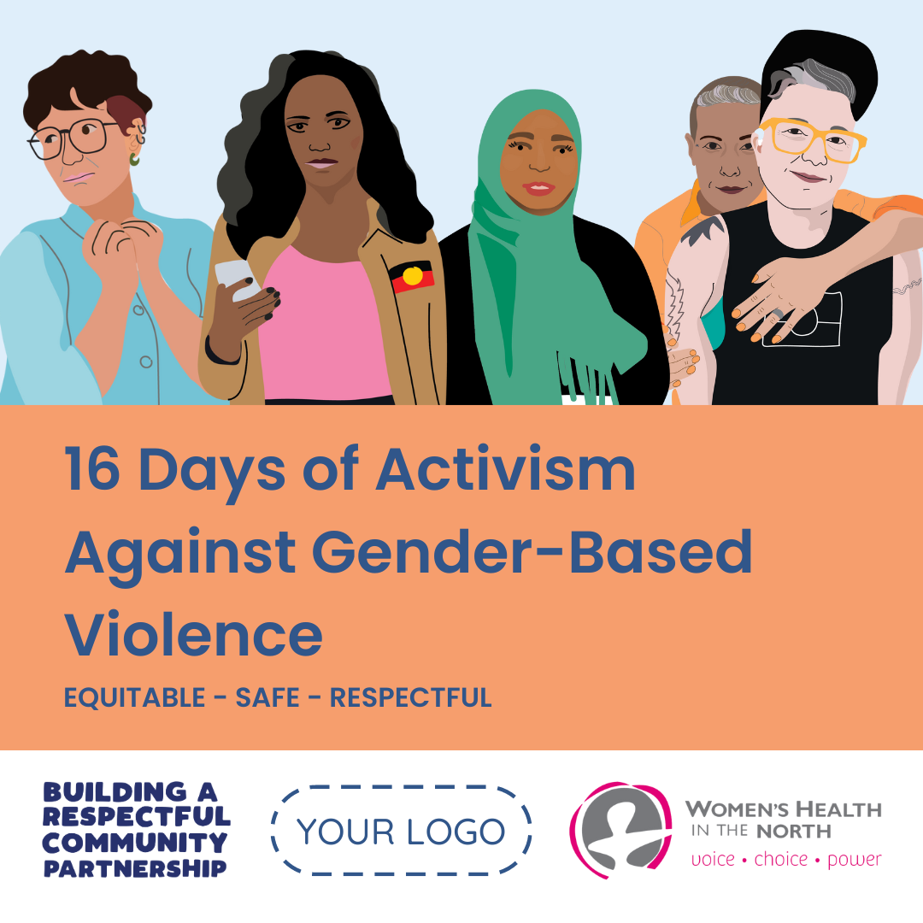

**Who is the audience for this campaign?**

These messages are broad and aimed at a general audience, including all those who work, live, study and play in our communities in the north and beyond.

**Can I change the captions?**

The messaging templates include suggested captions for you to use, which use values-based messaging. Please feel free to adapt and make use of the messaging templates as best fits in with your own organisation’s campaign plans and prevention of gender-based violence activities.

**Can I change the hashtags?**

You can add hashtags which are relevant to your organisation. Please include #BuildingaRespectfulCommunity #BRC16Days #16Days #16DaysofActivism #WHIN in all relevant posts as enables WHIN to measure use of the campaign.

**What is the tone of this campaign?**

The suggested captions convey a conversational and approachable tone. They draw on values-based messaging frameworks and seek to inspire the audience to enact the change that is being asked of them.

**Do I need to use all campaign resources?**

No, you can use all campaign resources or as many as fit to your organisation’s needs.

**Does it matter about the frequency and order of the posts?**

The campaign materials have been designed for one message per day during 16 Days of Activism of Gender-Based Violence (25 November–10 December). You may choose to use all or some of the messages, depending on what is the best fit for your organisation. Please note that the message order has been designed to build on previous messages to maximise understanding and engagement. Where possible try to maintain the sequence suggested in this toolkit. For example, use message nine, ‘Learn about the new affirmative consent laws in Victoria’ before message 11, ‘Practise talking about consent in everyday situations’.

The below three messages are date-sensitive and should be posted on those dates.

* 25 November: International Day for the Elimination Violence against Women
  + Message 1: 16 Days of Activism Against Gender-Based Violence: Equitable, safe, respectful
* 3 December: International Day of People with Disability
  + Message 10: Support flexible work arrangements for everyone
* 10 December: Human Rights Day
  + Message 16: Every day is a day of activism against gender-based violence

**I will not be able to complete the campaign survey by the deadline. What should I do?**

If you are unable to complete the campaign survey by 23 December, please contact [emily.s@whin.org.au](mailto:emily.s@whin.org.au).

**How will data from the campaign survey be used?**

The data you provide will be used to support WHIN’s 16 Days of Activism evaluation activities. The information you provide in the campaign survey will be kept private and confidential. It will be deidentified, aggregated across all partner’s data and used to support WHIN’s process improvement and reporting. No identifiable information will be shared beyond the WHIN project team without your organisation’s permission.

**If you have any further questions, contact Emily Sporik (**[**emily.s@whin.org.au**](mailto:emily.s@whin.org.au)**)**

## References

Flood, Michael, Dragiewicz, Molly, & Pease, Bob (2018) *Resistance and backlash to gender equality: An evidence review.* QUT Crime and Justice Research Centre, Australia.

Respect Victoria (2024) 16 Days of Activism Against Gender-Based Violence Toolkit 2024 <https://www.respectvictoria.vic.gov.au/sites/default/files/documents/202409/RV_16Days_Toolkit_2024_final.pdf>