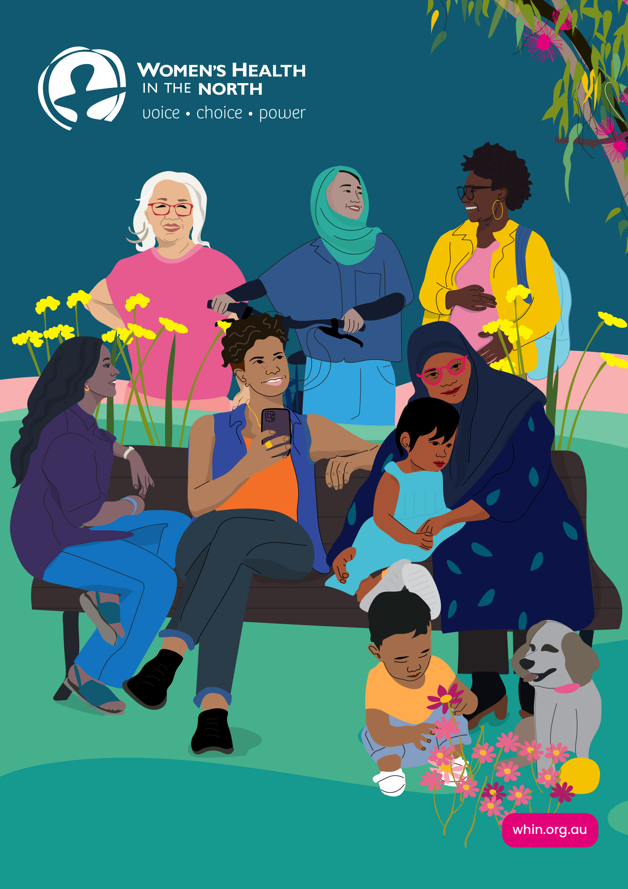
ANNUAL REPORT
2025

Acknowledgements
WHIN would like to acknowledge our funding partners:
- Department of Health, Victoria
- Department of Families, Fairness and Housing, Victoria
- Family Safety Victoria
- Respect Victoria
- Austin Health – North Eastern Public Health Unit
- Safe and Equal
- Australian Manufacturing Workers’ Union
- Ecstra Foundation
Women’s Health In the North acknowledges
the support of the Victorian Government.
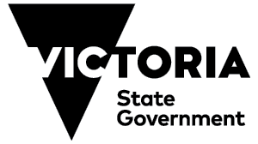

Acknowledgement of Country
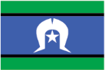
Women’s Health In the North acknowledges Victorian Aboriginal people as the Traditional Owners of the land on which we provide our services – the Wurundjeri Woi-wurrung people of the Kulin nation – and we pay our respects to their Elders past and present. WHIN acknowledges that Aboriginal sovereignty was never given up and that we stand on stolen land. We are committed to Aboriginal self-determination and to supporting Treaty and truth-telling processes.
We recognise the ongoing leadership role of the Aboriginal community on gender equality and the health, safety and wellbeing of women and gender diverse people. As First Peoples, Aboriginal Victorians are best placed to determine a culturally appropriate path to these in their communities.

Diversity and Inclusion

Women’s Health In the North believes that our diversity makes us stronger. We value different perspectives, experiences, knowledge, and ways of thinking and doing. At WHIN we work to promote an environment where people feel represented, valued and celebrated and we are steadfast in our continuous learning and improvement.
We are committed to an equitable approach that centres all women and gender diverse people, especially those who face multiple barriers to health, safety and wellbeing.

© Women’s Health In the North (2025)
This report and all its components (including formulas, data, images and text) are copyright. Apart from fair dealing for the purposes of research, planning or review as permitted under the Copyright Act 1968, no part may be reproduced, copied or transmitted in any form or by any means (electronic, mechanical or graphic) without the prior written permission of WHIN.
All requests and enquiries concerning reproduction and rights should be directed to the Chief Executive Officer.
Women’s Health In the North is a member of the Woman’s Health Services Network (WHSN), a collective of 12 state government-funded women’s health services. The WHSN operates as a coordinated, mutually-reinforcing network that provides both place-based and specialist services to create the best possible health outcomes for all women and gender diverse Victorians.
Annual report design and illustrations: Jacq Moon
Donate to WHIN at the WHIN ‘Make a donation’ webpage.
Contents
Acknowledgements 2
From our Chair and Interim CEO 6
Our Vision 10
Our Reconciliation Action Plan 12
Family Violence System Leadership 14
Preventing Gender-Based Violence 17
Gender Equity, Health and Wellbeing 19
Sexual and Reproductive Health 21
Family and Reproductive Rights Education Program 23
Economic Equality 24
Informing Community and Workforces: Our Resources 26
Our Impact and Reach 27
Financial Reports to year ended 30 June 2025 29
Independent Audit Report 29
Comprehensive Income Statement 31
Balance Sheet 32
Statement of Change of Equity 33
Statement of Cashflows 34
Responsible Persons Statement 35
Women’s Health in the North 36

From our Chair and Interim CEO

From our Chair, Petra Begnell

As Chair of the Board, I want to take a moment to reflect on a period of change for Women’s Health In the North (WHIN).
Change, while often challenging, is also an opportunity for renewal and growth – and we have embraced both in recent months. This has been a time to reflect on our past and our future, drawing on our values, and our commitment to the communities we serve. With every transition, we are reminded of the strength, resilience and adaptability of our team and our mission.
We offer our heartfelt thanks and farewell to our outgoing CEO, Helen Riseborough, whose leadership has shaped the organisation through critical years. Her dedication and vision have laid a strong foundation for what comes next, and we are deeply grateful for her service. We also extend our sincere appreciation to our Interim CEO, Tracy Taylor-Beck who stepped into the role with professionalism, steadiness and care. Her guidance during this time of transition has been instrumental in ensuring continuity and confidence across the organisation.

Looking ahead, we are delighted to welcome our new CEO, Carolyn Gillespie. She brings with her not only extensive experience in leadership for health and social impact but also a clear passion for equity, inclusion and community-driven change. This is a moment of new beginnings, and we are excited for what lies ahead. On behalf of the Board, thank you to our staff, partners and supporters for walking with us through change – your trust and commitment remain our greatest strength.
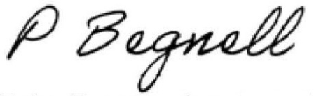
Petra Begnell
Chair of the Board of Directors

WHIN’s Board of Governance
Petra Begnell Chair
Kristen Boulton Deputy Chair (part-year)
Lucy Forwood Deputy Chair (part-year)
Karen Jones Treasurer
Helen Coleman
Yasmin Karaata
Cara Rose
Nicki Russell
Katherine Wositzky (co-opted)

From our Interim CEO, Tracy Taylor-Beck

This year has been one of reflection, renewal, and progress at WHIN. Following the departure of our longstanding CEO, Helen Riseborough, it has been both an honour and a privilege to guide the organisation through this time of change.
A major milestone came in December, when we moved into our new offices in Preston after 22 years on High Street. While leaving our old home was bittersweet, the relocation marks more than a change of address – it’s a bold step into a modern, connected and future-focused WHIN. This new space is a strong foundation, both practical and symbolic, for the next chapter of our work.
Throughout the year, we deepened connections between prevention and response across health promotion, family violence system leadership, and beyond. Working side-by-side with our partners and communities, we are laying the groundwork for lasting, systemic change. Alongside the move, we modernised systems, streamlined processes and embraced new technologies to work more collaboratively and responsively.
Our work this year has been grounded in inclusion, innovation and lived experience. Highlights included the Building Bridges Forum, which brought together over 100 practitioners, policymakers, and community members, and the Abortion Peer Support project, which created trauma-informed, safe spaces for 37 people. From gender-affirming financial literacy workshops to our Let’s Talk Money program for migrant, refugee, trans, and gender diverse communities, we championed economic equality as a public health priority.
This was also the first full year of WHIN’s Reconciliation Action Plan, with staff engaging deeply in truth-telling, cultural learning, and reflection – now woven into our everyday practice.

As I prepare to hand over to our incoming CEO, Carolyn Gillespie, I want to thank WHIN’s staff, Board, and partners for their dedication, care, and passion. WHIN is strong, resilient, and in wonderful hands as it begins this exciting new chapter.
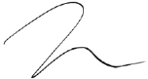
Tracy Taylor-Beck
Interim CEO

Our Vision
Women and gender diverse people in the north have voice, choice and power in all aspects of their health, safety and wellbeing.

The Northern Metropolitan Region,
Land of Traditional Custodians
the Wurundjeri Woi-wurrung people
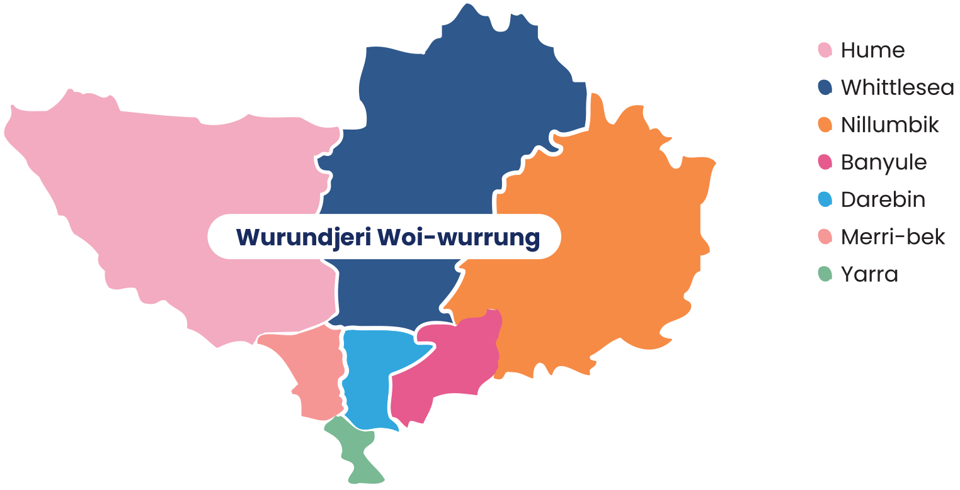
Over 544,500
women live in WHIN’s catchment area, the Northern Metropolitan Region (NMR) of Melbourne (Australian Bureau of Statistics 2022, Census figures).
The region covers over 1,600 square kilometres from inner city Richmond and Fitzroy to Sunbury, Whittlesea and the Kinglake Ranges.

Aboriginal and Torres Strait Islander Australians number 8,426 people in this region, approximately 51% of whom are female (approx 4,262).
Nearly half of all women and girls living in the NMR speak a language other than English at home, including: Arabic, Assyrian and Persian, Greek, Italian, Mandarin, Punjabi, Urdu, and Vietnamese
(State of Victoria, Mapping Languages Spoken in Victoria, 2023).

Our Reconciliation Action Plan
This year, WHIN is proud to have made a formal commitment to reconciliation through our first Reconciliation Action Plan (RAP).
Our work is underpinned by the principles of human rights, social justice, feminism, intersectionality and respect for environment and place. These values have motivated us to take a formal step towards reconciliation by committing to our Reflect RAP. First Nations Consultants Not Just A Consultancy led informative and impactful Truth Telling sessions for all staff and Board, which has been the foundation of our organisational cultural learning.
Staff cultural learning days have been a highlight of our RAP. For our RAP launch we learned and practised traditional weaving techniques from Mayapa Weaving. For National Reconciliation Week 2025 we took part in a walking tour in the Birrarung Marr to learn about First Nations’ land management, burning techniques and scar trees. On Country learning has helped us individually and collectively connect with First Nations’ history and motivated us to stop and reflect on the way we work.
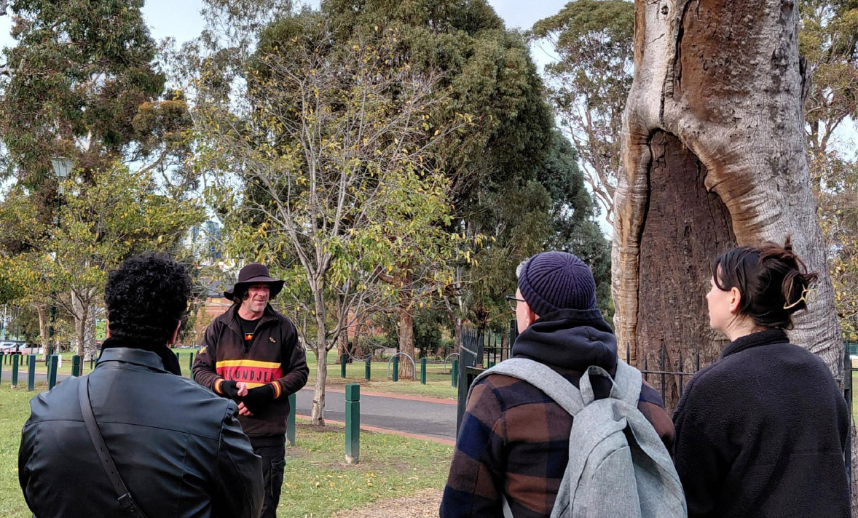
Image: During National Reconciliation Week, a First Nations walking tour guide shares the history and cultural significance of Scar Trees.

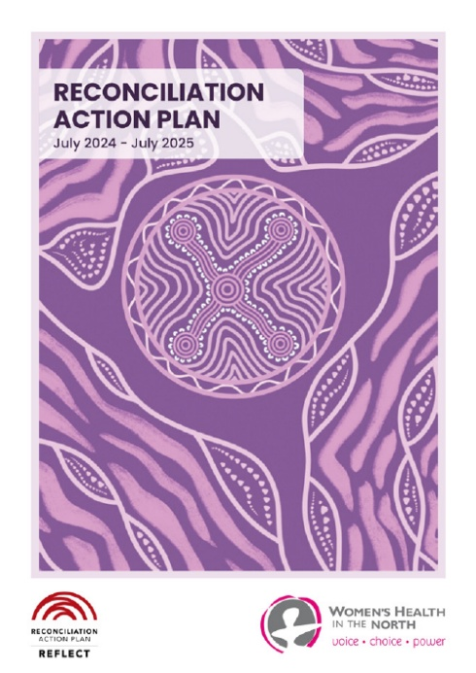
Image: WHIN’s Reconciliation Action Plan (July 2024 – July 2025). Cover artwork is by Kiewa Austin-Rioli. Kiewa is a proud Gunditjmara and Tiwi Islander woman.

Family Violence System Leadership
WHIN receives funding from the Victorian State Government for the delivery of the Northern Integrated Family Violence Services the (NIFVS) team and Regional Integration Committee (FVRIC).
WHIN holds a strategic role as the program fund holder, NIFVS team employer and sitting member on the NIFVS FVRIC, bringing a crucial focus on prevention to regional family violence system considerations and discussions.
The FVRIC unites regional specialist expertise to identify, inform and implement service system improvement initiatives across the NMR. The NIFVS team delivers workforce training and development initiatives and delivers on key priority actions strategically designed to promote enhanced service system integration and alignment to the Multi-Agency Risk Assessment and Management (MARAM) Framework. This combination of collaboration, innovation, and strategic leadership positions the FVRIC as a key player in advancing the Victorian State Government’s commitment to family violence reform across the NMR.
More information is available on the NIFVS website.

Key Achievements

Collaboration
- Consultation Paper: Family Violence and Personal Safety Reforms – Criminal Law Policy.
- Child Protection Referral Inquiry - Commission for Children and Young People.
- Best Practice Supervision Guidelines for Family Violence and Sexual Assault Workforces – Family Safety Victoria (FSV).
- Review Working Groups for the MARAM Practice Guides – FSV.
- Review Working Groups for the MARAM Collaborative Practice Training – Safe and Equal.
- Review of the FSV FVRIC Guidelines May 2022 – FSV.

Expert Family Violence Representation
- Local Site Executive Committees for Hume Merri-bek Area and North Eastern Melbourne Area.
- Hume Merri-bek Smart Services Network.
- Dhelk-Dja North Metro Action Group.
- Northern Homelessness Network.
- Integrated Family Violence Networks.
- Local Government Area Family Violence Networks.
- North East Mental Health Services Coordination Alliance.

Joint Family Violence Resource Development
- Abuse of Older People Response Toolkit – a Holstep Health, WIFVC and NIFVS partnership initiative.

Workforce Training and Development
- 343 practitioner professionals were trained in MARAM Collaborative Practice.
- Curriculum development and pilot delivery of a region-specific Advanced MARAM Collaborative Practice training package.
- Delivery of a range of Lunch and Learns to over 230 attendees.
- Delivery of a range of Communities of Practices to Family Violence practitioners.

Building Bridges Forum 2024
- Online forum delivered to more than 100 sector professionals including sessions on adults using violence, family violence information sharing schemes, embedding cultural safety and respect with Aboriginal and Torres Strait Islander communities, and culturally informed care when working with migrant and refugee women.

Family Violence Counselling
- Family violence recovery program for victim/survivors.
- Coordination of the regional Counselling Support Alliance (CSA) with seven Community Health Services and three Specialist Family Violence Services organisational members through the NIFVS Team.
- More than 500 victim survivors of family violence received therapeutic counselling or group work recovery services.

Preventing Gender-Based Violence
WHIN’s Prevention of Gender-Based Violence and Sexual and Reproductive Health teams collaborated to create a new campaign for 16 Days of Activism against Gender-Based Violence, 2024. We led a trans and gender diverse inclusive ‘Equitable, Safe, Respectful’ social media campaign across Melbourne’s northern region.
We called for action to promote gender equity, challenge gender stereotypes and the condoning of violence, and support for reproductive choice and affirmative consent. We developed a
values-based messaging social media toolkit for use by our Building a Respectful Community (BRC) partnership. The campaign had a reach of 21,365 and 927 engagements.
Additionally, we ran Affirmative Consent Essentials workshops to 26 participants who work with young people in community settings. Following this training, 100% of participants reported having an increased understanding of consent and the importance of affirmative consent.
This year, we also
- developed and launched the Allyship in Action Outcomes Paper, in partnership with Zoe Belle Gender Collective.
- developed with BRC partner organisations, the BRC Evaluation Framework and Action Plan 2024–26.
We released ConSensual, a zine that was created as part of the Taking ACtion: Affirmative Consent in the North project. ConSensual is made by young people for young people and explores what affirmative consent means through art, writing and facts.
ConSensual was launched at a community event co-designed and led by the Taking ACtion Youth Action Group (YAG). Over 70 people joined us for the event to hear from keynote speaker Dee Salmin (host of Triple J’s The Hook Up), YAG members and youth panelists, and to participate in three creative workshops on the theme of consent.
We’ve distributed over 500 printed copies of ConSensual since the launch!
See our Preventing Gender-Based Violence webpage for more information.
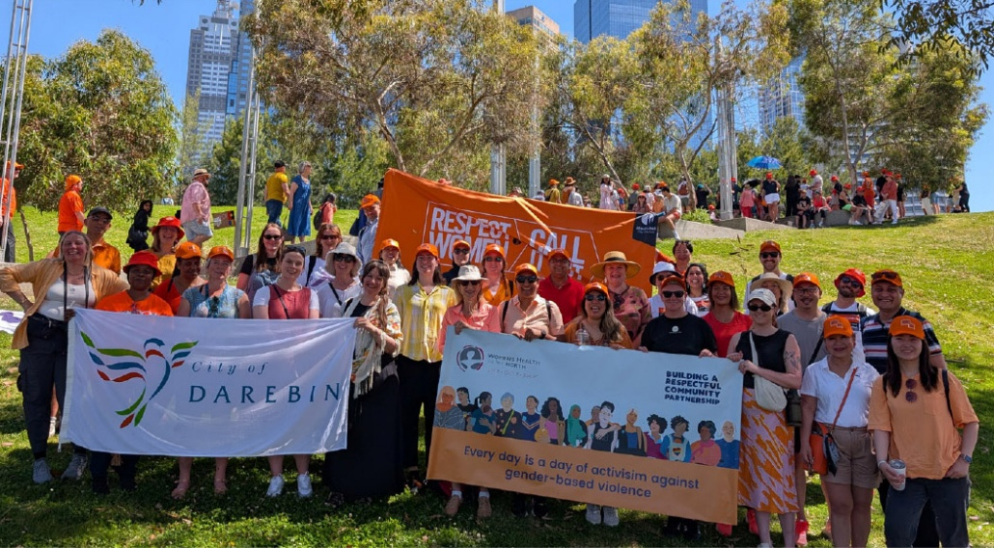
Image: WHIN staff join other organisations for the
2024 Walk Against Family Violence in Melbourne.
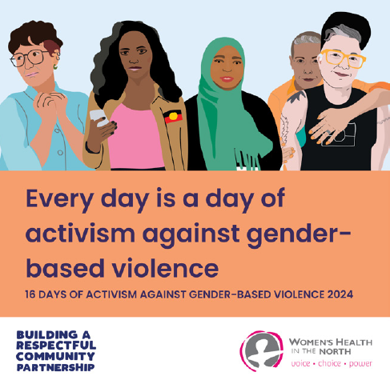
Image: Social media tile used as part of
WHIN’s 16 Days of Activism campaign

Gender Equity, Health and Wellbeing
WHIN completed and evaluated our Student-led Gender Equality Pilot project, highlighting successes, challenges, outcomes, and recommendations. Guided by the Respectful Relationships education framework, the pilot project sought to empower Grade 6 students at Fitzroy North Primary School to identify and address gender inequality through a student-led approach.
The pilot was implemented by WHIN, Department of Education Respectful Relationships North Eastern Melbourne Area, cohealth, and the Neighbourhood Justice Centre on behalf of the Building a Respectful Community partnership.
WHIN chairs the Prevention in Schools Working Group, implementing evaluation recommendations with the development of a project toolkit for publication in the second half of 2025.
This year, we also
- facilitated Gender Audit Training for sport and recreation staff at local councils. After introducing gender equity in sport, we shared practical steps for conducting a gender audit and how to manage resistance and backlash when implementing prevention of gender-based violence initiatives. Participants learnt the critical role sports settings and clubs play in preventing gender-based violence.
- designed and delivered gender equality training to leadership and staff at Hume City Council Early Years program. We also set up a Community of Practice for the Early Years staff, as part of Hume council’s Gender Equity in the Early Years Capability-Building program.
- designed and conducted gender impact assessment training for Whittlesea Council, providing expert Gender Impact Assessment consultation advice on the 25/26 Council plan.
- partnered with Hume City Council, Sunbury Cobaw Community Health and DPV Health to facilitate the Hume Gender Equity in Sport Network.
See our Gender Equity webpage for more information.
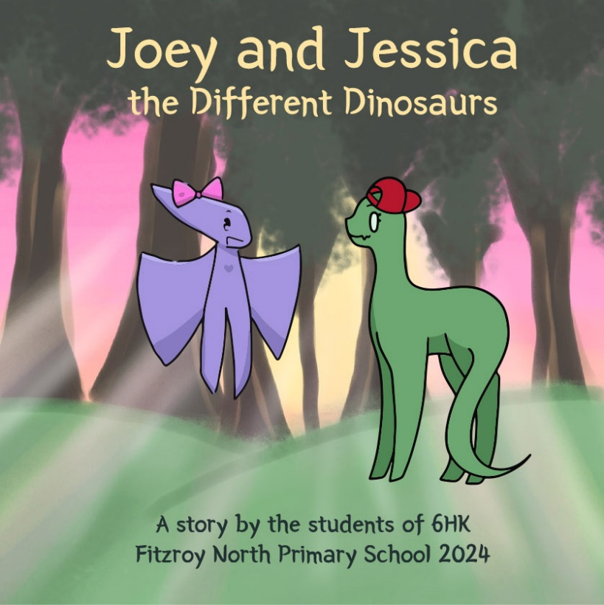
Image: Joey and Jessica the Different Dinosaurs was storyboarded, written and illustrated by students at Fitzroy North Primary School.

Sexual and Reproductive Health
WHIN and The Abortion Project have successfully established Victoria’s first pro-choice post-abortion peer support group. Running fortnightly, the peer support group fills a gap in post-abortion support, building community connection and promoting better understanding of abortion supports and services.
Within an inclusive and trauma-informed environment, the group explores different themes in each session including identity, stigma, service provider experiences, abortion discourse in music and media, support systems and much more. The peer-led, lived-experience model for the support group has been crucial to ensuring a safe and non-judgmental environment, which was reflected in project evaluation. Find out more at The Abortion Project website.
“My abortion and the fallout was one of the most isolating times of my life, and so it has been amazing to talk with people who have been in the same situation and can truly understand.”
Participant in the abortion peer support group
This year, we also
- led the sector-wide project to develop Framing Sexual and Reproductive Health, a message guide to support effective and persuasive health communication
- delivered a unique series of community workshops, Pleasure for Every Body, in partnership with Women with Disabilities Victoria.
See our Sexual and Reproductive Health webpage for more information.
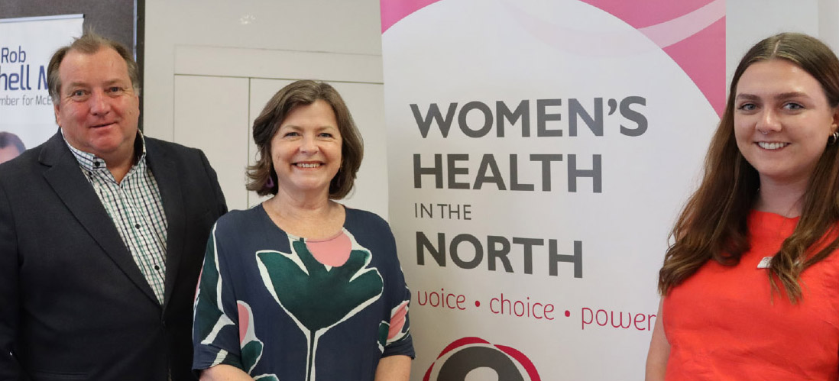
Image: WHIN Coordinator, Sexual and Reproductive Health, Tilly Mahoney, (right) with The Hon. Ged Kearney MP (centre)
and Mr Rob Mitchell MP (left) at a community forum in Mernda.

Family and Reproductive Rights Education Program
The Family and Reproductive Rights Education Program (FARREP) works to prevent female genital cutting (FGC) and supports the health and wellbeing of women and girls. Led by our dedicated health promotion team and FARREP worker Intesar, free community education sessions on respectful relationships, sexual and reproductive health, FGC, and mental health have fostered openness, acceptance, and confidence to seek support. These sessions create space for people to listen, share, and connect, building trust and solidarity and show the power of working together to support women and girls from communities in which FGC occurs.
This year, we also
- led the planning and delivery of a community event Our Voices Our Health to acknowledge the International Day of Zero Tolerance for Female Genital Cutting with the North West FARREP Partnership, attended by over 50 community members.
- delivered 4 professional development sessions about refugee women’s health and FGC to 59 community service and health professionals.
- provided 81 one-on-one phone/online consultations and needs analyses with members of communities that traditionally practice FGC.

Economic Equality
The Economic Equality team delivers community-centred programs that advance financial capability and wellbeing, gender equity, and systems-level change across Victoria.

The Cost of Gender Affirmation:
Figuring It All Out
Combining WHIN’s economic equality and sexual and reproductive health expertise, we provided financial literacy workshops to trans and gender diverse community members and allies. The two sessions were delivered in person and online, engaging 33 participants across Victoria and interstate.
The sessions provided a culturally safe, gender-affirming learning environment that demystified the medical, systemic and hidden costs of gender affirmation. Our workshops empowered participants to navigate financial decisions with greater confidence.
Covering topics such as costs and options related to hormones, top/bottom surgery, facial and vocal procedures, gender marker changes, and financial wellbeing, participants left with practical tools to manage their finances and clearer pathways to support.
The sessions are a model for future delivery in collaboration with trans and gender diverse communities.
This year, we also
- extended the rollout of our Let’s Talk Money Train-the-Trainer model, equipping over 10 workforce professionals with culturally safe, financial literacy facilitation skills and tools for delivery in their own communities.
- launched the Economic Equality Bulletin, a quarterly e-newsletter featuring sector reports that elevate economic equality as a core public health issue.
- developed and launched WHIN’s Economic Equality Strategy: Impact Statement to work towards economic equality for women and gender diverse people in Victoria.
- shared the stage with The Hon. Andrew Giles MP and The Hon. Ged Kearney MP to elevate economic equality and financial hardship as core public health issues.
- celebrated Shazia Syed, WHIN’s Coordinator, Financial Capability, being inducted into the Victorian Multicultural Honour Roll.
See our Economic Equality website, incorporating Let’s Talk Money, for more information.
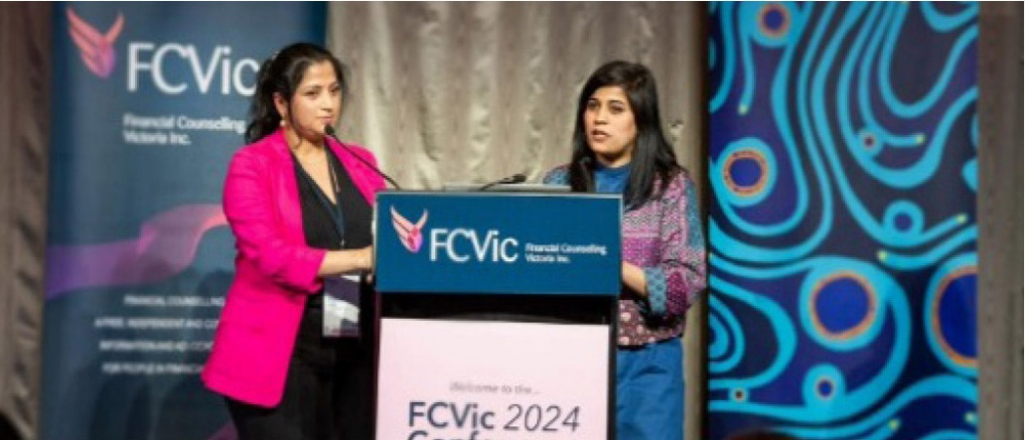
Image: WHIN’s Manager, Economic Equality, Manasi Wagh, with Coordinator, Financial Capability, Shazia Syed, presenting
at the Financial Counselling Victoria conference in 2024.

Informing Community and Workforces: Our Resources
15 resources produced,
downloadable from WHIN’s resources webpage and the Northern Integrated Family Violence Services Partnership resources webpage, including:
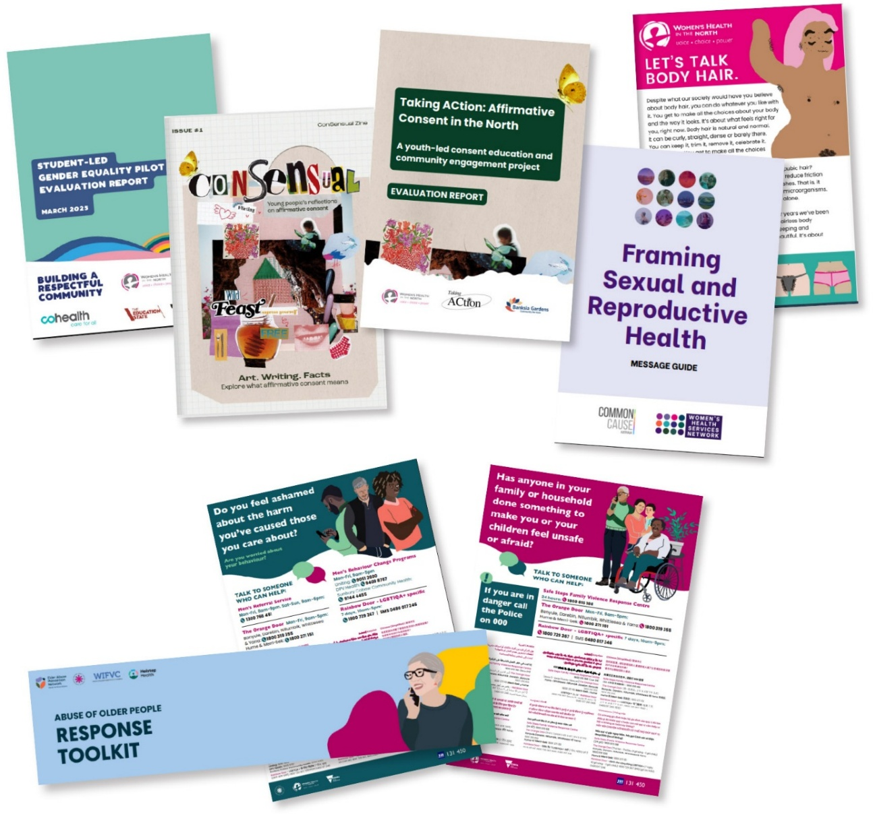
“In working with other stakeholders in our region, this message guide offers clear tips for how we can collectively structure our communications about SRH [sexual and reproductive health] work to improve engagement in communities.”
Attendee of Framing Sexual and Reproductive Health launch

Our Impact and Reach
“I learn to make budget for needs and wants. This workshop was so informative and empowering, I finally understand how to manage my money better.”
Participant in Let’s Talk Money workshop
- 51 Training/educations sessions delivered
- Total training participants/attendees 2597 attendees
- 39 WHIN events
- Contributed to 52 committees/advisory groups
- 4,953 total e-news subscribers
- 208 submissions/statements/consultations by WHIN staff
- 18 external conference/forum presentations delivered
- 283 WHIN members
- Over 46,000 unique users visited WHIN’s websites
Across WHIN’s social media (Instagram, Facebook and LinkedIn) we have over 6,870 followers and our posts and content has been displayed over 121,200 times.
Users have engaged (liked, commented, shared) our content over 9,200 times.

WHIN convenes, leads and resources
11 Strategic Partnerships including:
- Building a Respectful Community (BRC) Partnership: 28 organisations working together to prevent gender-based violence across the NMR.
- NIFVS Family Violence Regional Integration Committee (Northern Integrated Family Violence Services) to advance family violence system leadership.
- NIFVS Counselling and Support Alliance, comprising community health and specialist family violence services, providing counselling and group work to over 500 victim survivors.
- Student-led Gender Equality Evaluation Working Group with the Department of Education, cohealth and Neighbourhood Justice Centre.
- Taking ACtion Youth Action Group: supporting young people to understand affirmative consent.
- Allyship in Action Working Group: focuses on building bystander action for trans and gender diverse equity among BRC partner organisations.
- Gender Equity in the Early Years Community of Practice:
Hume City Council
- NIFVS Working with Infants and Children experiencing Family Violence Community of Practice with Berry Street.
- NIFVS Make it Mainstream Community of Practice with Jackson Fairchild.

Financial Reports
to year ended 30 June 2025

Independent Audit Report
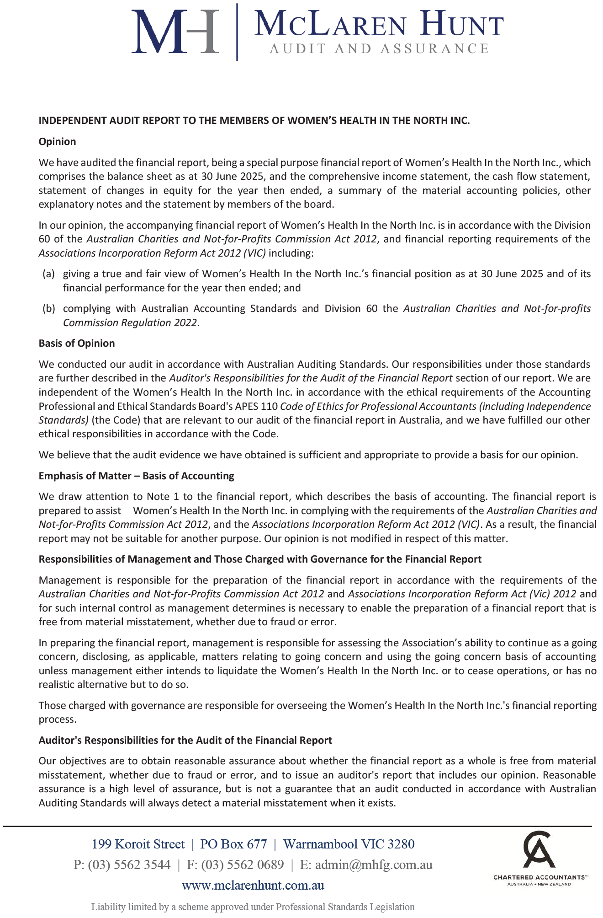
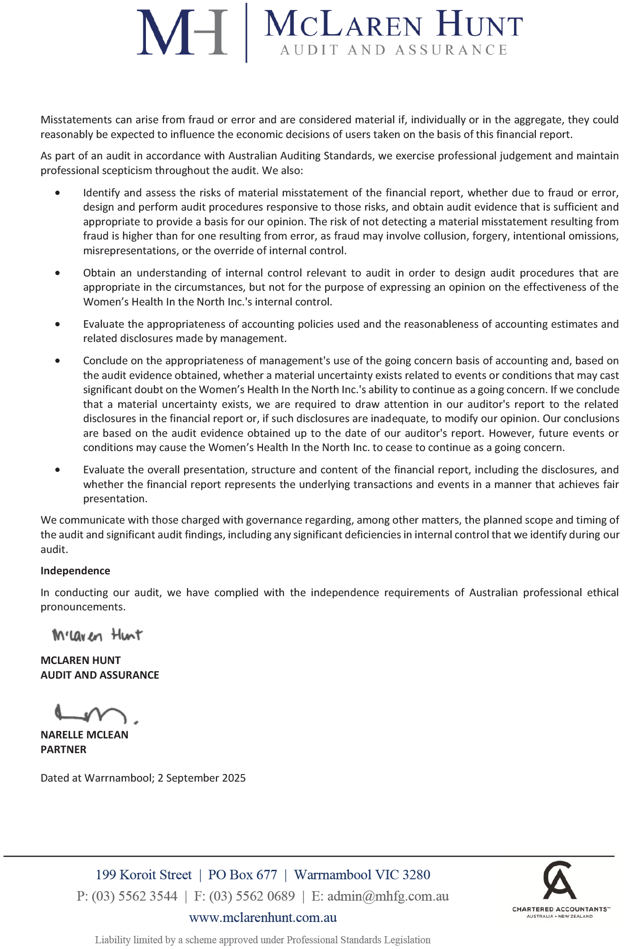

Comprehensive Income Statement
for the Year Ended 30 June 2025
 | 2025  $ | 2024  $
Income
Dept of Health/ Department of Families,  Fairness and Housing | 3,091,620 | 3,179,617
Special Projects | 604,888 | 652,060
Interest Received | 69,010 | 74,906
Other | 288,922 | 71,380
 | 4,054,441 | 3,977,963
Expenditure
Employee Benefits Expense | 2,509,830 | 2,628,472
Project Costs | 807,562 | 730,752
Consultancy Fees | 285,815 | 160,377
Administration | 209,518 | 101,832
Occupancy Costs | 61,151 | 105,392
Depreciation and Amortisation | 82,853 | 24,536
Motor Vehicle Expenses | 10,628 | 11,494
Printing & Production | 22,564 | 30,318
Health Education Resources | 6,453 | 2,764
 | 3,996,376 | 3,795,937
Comprehensive Result | 58,065 | 182,026

Balance Sheet
as at 30 June 2025
 | 2025  $ | 2024  $
Assets
Current Assets
Cash and Cash Equivalents | 472,404 | 1,578,523
Trade and Other Receivables | 281,752 | 121,469
Financial Assets | 2,200,000 | 1,200,000
 | 2,954,156 | 2,899,992
Non-Current Assets
Plant and Equipment | 17,446 | 21,442
Right of Use Assets | 170,857 | -
 | 188,304 | 21,442
Total Assets | 3,142,459 | 2,921,434
Liabilities
Current Liabilities
Trade and Other Payables | 212,525 | 251,790
Other Liabilities | 362,805 | 308,735
Lease Liability | 120,556 | -
Leave Entitlements | 354,919 | 373,965
 | 1,050,804 | 934,490
Non Current Liabilities
Lease Liability | 52,305 | -
Leave Entitlements | 24,636 | 30,295
 | 76,941 | 30,295
Total Liabilities | 1,127,745 | 964,785
Net Assets | 2,014,714 | 1,956,649
Equity
Retained Earnings | 2,014,714 | 1,956,649
Total Equity | 2,014,714 | 1,956,649

Statement of Change of Equity
for the year ended 30 June 2025
 | 2025  $ | 2024  $
Total Equity at the Beginning of the Financial Year | 1,956,649 | 1,774,623
Comprehensive Result | 58,065 | 182,026
Total Equity at the End of the Financial year | 2,014,714 | 1,956,649

Statement of Cashflows
for the year ended 30 June 2025
 | 2025  $ | 2024  $
Cash Flow From Operating Activities
Receipts from Government grants (Recurrent) | 3,460,259 | 3,405,771
Receipts from other sources | 806,880 | 781,456
GST received/(paid) | (235,758) | (278,040)
Payments to suppliers and employees | (4,198,006) | (3,876,844)
Interest received | 69,010 | 74,906
Net cash provided by (used in) operating activities (Note 2) | (97,615) | 107,249
Cash Flow From Investing Activities
Payments for plant, equipment and motor vehicles | (8,505) | (1,669)
Proceeds from (payment for) investments | (1,000,000) | -
Net cash provided by (used in) investing activities | (1,008,505) | (1,669)
Net increase (decrease) in cash held | (1,106,119) | 105,580
Cash at beginning of year | 1,578,523 | 1,472,943
Cash at end of reporting period | 472,404 | 1,578,523

Responsible Persons Statement
for the year ended 30 June 2025

Declaration
The financial statements and notes forming part of this document fairly present the organisation's financial position at 30th June 2025 and its performance for the year ended on that date in accordance with the Australian Charities and Not-for-profits Commission Act 2012, and:
- comply with Australian Accounting Standards; and
- give a true and fair view of the financial position of the entity as at 30th June 2025 and of its performance the year ended on that date; and
- the financial statements satisfy the requirements of the Australian Charities and Not-for-profits Commission Act 2012.
There are reasonable grounds to believe that the organisation will be able to pay its debts as and when they become due and payable.
This declaration is signed in accordance with subs 60.15(2) of the Australian Charities and Not-for-profits Commission Regulation 2013.

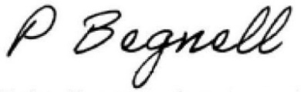
Chairperson
Petra Begnell
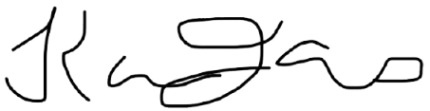
Treasurer
Karen Jones
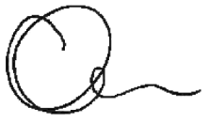
Chief Executive Officer
Carolyn Gillespie

Dated at Melbourne on 2nd September 2025.

Women’s Health In the North

Reg. No. A0026656G
ABN 724 189 216 51
(03) 9484 1666
info@whin.org.au
www.whin.org.au

Level 2/266 Raglan Street,
Preston Victoria 3072
 WHIN on Facebook
 WHIN on LinkedIn
 WHIN on Instagram
 WHIN on YouTube

